

**SIX WEEKS SUMMER TRAINING**

**REPORT**

on

# *Medicine Reminder App*

Submitted by

**Devansh Gupta**

**Registration No: 11909327**

**Program Name: B. Tech CSE**

Under the Guidance of

**SUDIPTA PAITANDI**

**School of Computer Science & Engineering**

**Lovely Professional University**

**Punjab**

(4thJune-15thJuly, 2021)

**DECLARATION**

I hereby declare that I have completed my six weeks summer training at **Fifth Force** from June 4’ 2021 to July 15’ 2021 under the guidance of Sudipta Paitandi.

I have declared that I have worked will full dedication during these six weeks of training and

my earning outcomes fulfil the requirements of training for the award of degree of B.Tech CSE, Lovely Professional University, Phagwara.

....………………………

(Signature of student)

Name of student: Devansh Gupta

Registration No. 11909327

Date: ……………….

**CERTIFICATE**

**Table of contents**

|  |  |
| --- | --- |
| **Topic** | **Page No** |
| 1.0 Introduction  1.1 Purpose  1.2 Modules  2.0 Technology Learnt  2.1 Benefits of Android Development  2.2 Real Life Applications  3. Reason for choosing this technology  4. Profile of the problem  5.Existing System  6.0 Problem Analysis  6.1 Product Definition  6.2 Feasibility Analysis  7. Software requirement analysis  7.1 Android Studio  7.2 JAVA  8. Design  8.1 Flow chart  8.2 Data Flow Diagram (DFD)  9. Implementation  10. Learning Outcomes from Technology Learnt  11. Gantt Chart  12. Project Legacy  13. Bibliography | 5  6  7  8  9  12  13  15  16  17  17  22  23  23  27  28  28  29  31  33  34  35  36 |

**1.0 INTRODUCTION**

This report discusses the work done and topics learned during the summer training organized by “**Fifth Force**” organization on **Android App Development**.

The summer training was held between 4th June 2021 to 15th July 2021.

This is an Android-based application in which an automatic alarm ringing system is implemented. It focuses on doctor and patient interaction. Patients need not remember their medicine dosage timings as they can set an alarm on their dosage timings. The alarm can be set for multiple medicines and timings including date, time and medicine description. A notification will be sent to them through email or message inside the system preferably chosen by the patients. They can search doctor disease wise. The patients will get the contact details of doctors as per their availability. Also, the users can see different articles related to medical fields and health care tips. The system focuses on easy navigation and good user interface. Many such Medical Reminder Systems have been developed where a new hardware is required but, in our work, we have made an attempt to develop a system which is economical, time-saving and supports medication adherence.

In our developing and technology dependent life we totally rely on gadgets especially smart phones. Today everyone has a smart phone. With this we get an opportunity to use technology in a better way so that it can be made useful to us. And it plays an important part in our daily life and helps us staying fit in many ways.

In this report I will discuss all the progress and work done by me for the project. During development of the project, I faced many problems. From problems I got a lot to learn, and I would like to thank my course coordinator who was always there to help me out from any problem regarding project.

**1.1 Purpose**

The category of patients involves all human beings-teachers, students, businessmen, housewives, children and also all of us have a busy hectic schedule. Today’s life is full of responsibilities and stress. So, people are prone to diseases of different types and it is our duty to make ourselves stay fit and healthy. If the patient stays at home then he or she might get someone to look after him/her but when one is not at home, is out of the city or state away from home then it is hard for the family members to call them and remind them their dosage timings every time.

The remarkable problem is that patients forget to take the proper medicines in proper proportion and in proper time. Medication adherence, which refers to the degree or extent to which a patient takes the right medication at the right time according to a doctor’s prescription, has recently emerged as a serious issue because many studies have reported that non-adherence may critically affect the patient, thereby raising medical costs. Medication nonadherence is a common, complex, and costly problem that contributes to poor treatment outcomes and consumes health care resources.

So we are introducing an Android application whose objective is to remind the patients of their dosage timings through Alarm Ringing system so that they can stay fit and healthy. Through navigation they can search doctors and hospitals and contact details so that they can easily get proper treatment on time. This application focusses on the people who forget to take medicines on time. It allows users to set an alarm along with the fields of date, time and medicine description which will allow them to set alarm for multiple medicines at different time intervals.

**1.2 Modules**

The site will contain the following features:

* Home Page
* Calendar
* Add Medicine
* Add time
* Type of Medicine
* Select days of week
* View by day
* Medicine Schedule
* Apply Filter
* Set Alarm
* All Medicine

**1.3 Hardware Requirements:**

* Processor – i5
* Hard Disk – 50 GB
* Memory – 4GB RAM
* Monitor

**1.5 Software Requirement:**

* Android 5 or higher
* 16 MB RAM Minimum
* 50 MB storage

**2.0 Technology Learnt**

Android App Development is the process in which android apps are developed and designed for the devices running on android operating system. Android devices are widely used around the world more than any other.

Android, the open-source platform for smartphones and tablets, is engendering zest across the mobile space. The operating system is open source, based on Linux and is compatible with a JAVA Library. It was developed by Google and the Open Handset Alliance. Moreover, Android provides an efficient open marketplace and an excellent opportunity for third party android app developers. The operating system’s reach, huge, engaged and global audience is a result of its efficient process for building and launching apps makes it a simpler process than other operating systems.

With over 85 percent market share worldwide, the Android OS dominates the thriving mobile platform. As Google comes with newer versions containing enterprise-friendly features and enhanced security, entrepreneurs seem ready to have a piece of pie with the help of a customized Android app development. Today, Google Play has over 3.3 million apps, and the number is steadily increasing.

In other words, Android app development services are thriving at a tremendous pace. Here we will go through the top ten business benefits that compel the businesspersons to opt for feature-rich and future-ready Android app development.

**2.1 Benefits of Android Development**

**1. Higher Role**

As an open-source platform, Android’s Software Development Kit (SDK) is readily available to developers. Further, Android app development is cost-effective. We can broadly classify the development cycle into three phases-

* App Design and Development
* App testing
* App Deployment

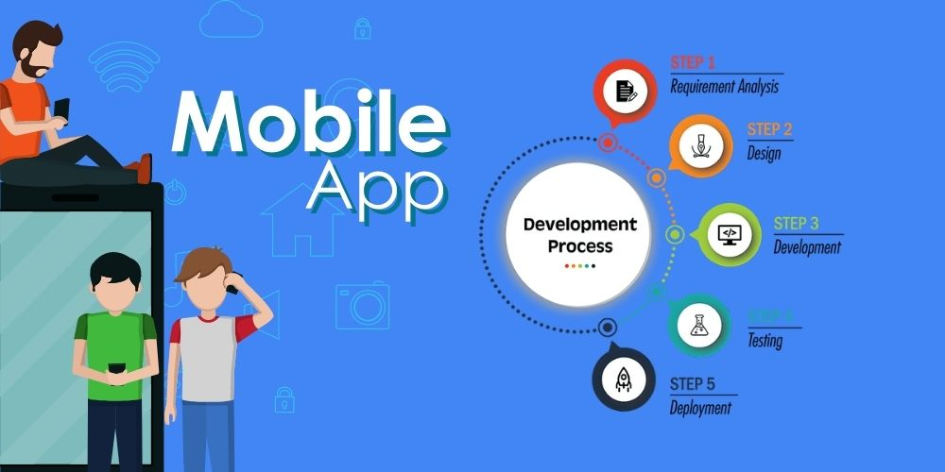

The entire development cycle is not much pricey. What’s more, Android app developers can readily implement the material design, and you can get an engaging and interactive Android app at a lower cost for addressing a huge audience globally.

**2. Android Mobile App Enhance Security and Easy Marketing**

Google has rolled out many business-friendly features in the recent updates of Android started from Lollipop. Today, this platform stands firm against its Apple counterpart regarding data security. It is now difficult for malware to locate the data structure. Also, an automated system can send periodic notifications to the users and keep them updated. What’s more, you can readily promote your Android app thanks to the platform’s prevalence. In a way, Android OS can give you both safety and promotional advantage.

**3. Easy Customization**

Android is a versatile platform with a high flexibility and easy customization options. All you get is an innovative and interesting enterprise app with diverse functionalities. Android is a robust OS that can integrate all types of modifications ranging from simple to complex.

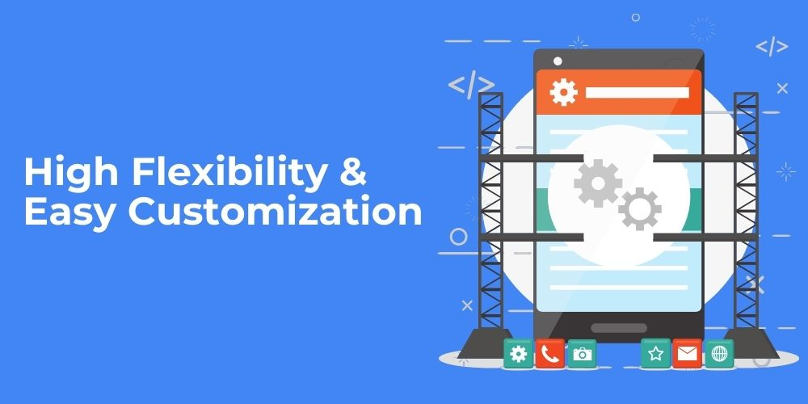

Android also enables you to integrate and update various tools and data management functions to meet the changing requirements.

**4. Wearable Device Advantage from android app development**

[Wearable technology](https://en.wikipedia.org/wiki/Wearable_technology) becomes a new norm in the corporate sector.. Smartwatch notifications also become common and they are managed by Android mobile apps.

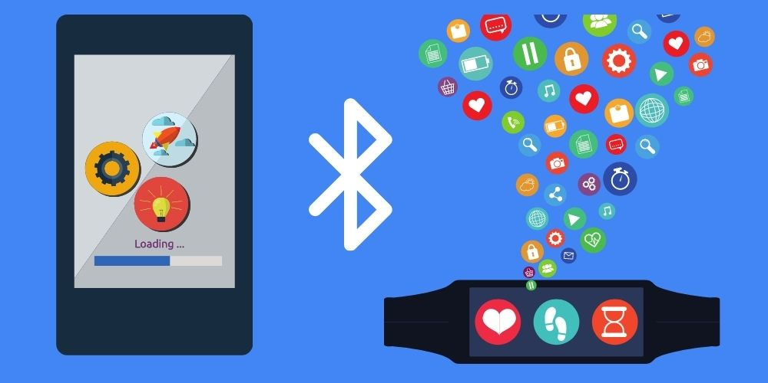

**5. Evolving Platform**

Do you know that Android is still evolving? Android smartphones are built by several renowned companies like Samsung. They keep on bringing new features to stay firm amid growing competition, and the Android developers’ community quickly gets adapted to them.

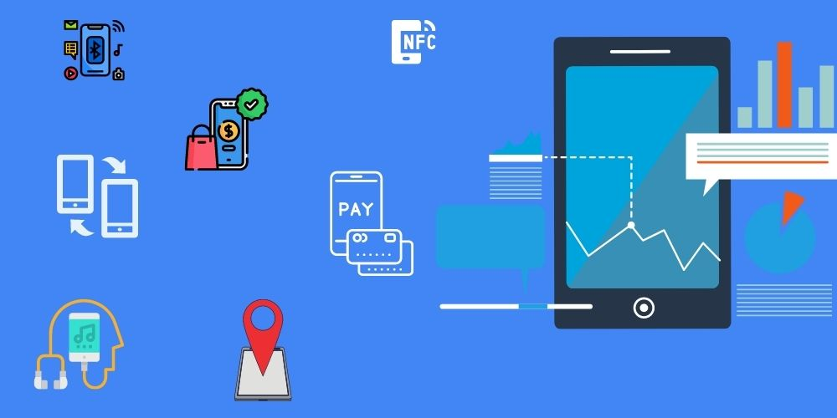

**6. Installation of Custom ROMs**

It is easy to change the app’s appearance and performance with custom ROMs. You can customize the Android devices as per your business model and strategies by installing custom ROMs. Most of ROMs are completely free as they are made by a group of core developers as a pastime activity.

**7. All things Google**

This is one of the biggest advantages you can get with an Android app. Though many Google services are also available in iOS, the deep integration is still lacking in it. You can give the benefits of Google’s apps and features to your app users with a tailored Android app for your business. Also, whenever Google will launch a new service or app, it can seamlessly work on your Android app with ease.

**2.2 Real Life Applications**

There are countless example of application of android. All the digital things like smartphones, watches, Smart TV, many home appliances all are working on android operating system. Hence all of them need android app to do works aur perform a specific task.

Some examples are:

* Custom Android App Development
* Android Game Development
* Social Media Android App Development
* Enterprise Android App Development
* Android Widget Development
* Android App Support

Some apps developed under android app development:

**Play store Google Assistant**

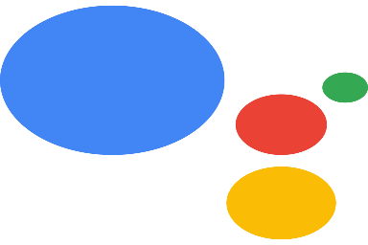

**PUBG India YouTube**

 

**3. Reason for choosing this technology**

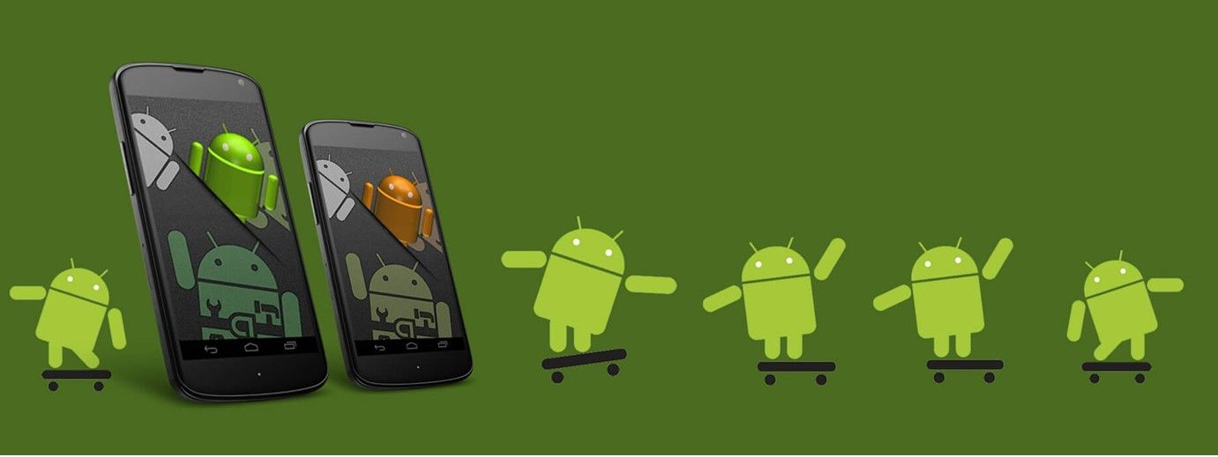

**1.Open Source**

The Android platform for app development is open source which means it is royalty-free and isn’t restricted to just the Android Market. This gives a lot of liberty and freedom to innovate and be creative. The SDK architecture is a major advantage that permits you to communicate with the community on future expansions of mobile app development. You can install Android apps from any source that increases the possibilities of the platform.

**2.Pro-active Testing**

The integration of the platform is easy and the SDK lets you install & run your app on the device each time you compile. This is an added advantage for the developer to test his/her application on multiple devices without additional costs making the platform cost-effective as well. The developer can integrate and tweak the application on the Android platform according to their or their clients’ requirements.

**3.Easy Adoption & Launching**

Basically, if you can code in Java then you can easily develop an application on the Android platform. It has turned out that for programmers it’s easy to adopt and script code for mobile apps on the Android platform. The process of launching your application is easy & simple. All you need to do is register yourself as a developer then submit your .apk file. That’s how easily accessible the humongous market of Android is for everyone. Moreover, the Android platform permits rooting Android-based devices & installation of custom ROMs. On the other hand, in the case of iPhone rooting is termed “jailbreaking”, that’s an actual crime in the USA.

**4. Multiple Distribution & Sales Channel**

With the Android platform, you aren’t restricted to just the Android Market instead you can deploy it in various ways. The platform allows you to use a third-party marketplace for your distribution and sales channel by developing new application stores or straight away putting it on your website. It is your application and the platform lets you choose the way you wish to reach potential customers with your promotional strategy in order to convert them into end-users.

**5.Popular Platform**

84.7% of mobile devices are based on the Android platform creating a lot of scope for app development’s bright future. The platform is very user-friendly and that has made it extremely popular among the developers. The number of users with Android devices is increasing, hence, the developers in the industry enjoy the benefit of heavy downloads of their creation. This has made the platform highly popular.

**4 Profile of the problem:**

The category of patients involves all human beings-teachers, students, businessmen, housewives, children and all of us have a busy hectic schedule. Today’s life is full of responsibilities and stress. So, people are prone to diseases of different types, and it is our duty to make ourselves stay fit and healthy. If the patient stays at home, then he or she might get someone to look after him/her but when one is not at home, is out of the city or state away from home then it is hard for the family members to call them and remind them their dosage timings every time.

Due to hectic schedule people forget to take medicines on time which cause them to loos there health eventually.

Many such Medical Reminder Systems have been developed where a new hardware is required but, in our work, we have made an attempt to develop a system which is economical, time-saving and supports medication adherence. Our system focuses on easy navigation and good user interface. Anyone of any age group can easily use the app as its interface is user friendly and easy to understand.

**5.0 Existing System**

MedsLog, an application only for the iPhone users, is very complex application as compared to

others. The users need to spend much more time with the software to understand its

functionalities in a proper manner. The main problem with the system is it has “consumed by”

box where a user is supposed to fill his username in the provided space. Still the system shows

“no people” [12]. In contrast the proposed system is very much user friendly because it is made

for the people of all ages. So one can utilize the time in using the system rather than wasting the

time in understanding the software. The users can easily manage their profile.

MotionPHR Health Record Manager which is available for $10 for full version on Android and

iPhone and $2 for a Lite version on iPhone, is less rated by the users because of the problem

about the flaws in the reminder system and a service that backs up user data [12]. Medsy is also

an application which tries to provide medicine remaindering system but it is loaded with less

features. If the user is supposed to take a medicine three times a day then this application does not

allow to set alarm accordingly. But in our work this disadvantage has been overcome by allowing

users to set multiple alarms and notifications [12].

Another application DoseCast is loaded with some good features but it fails to provide

notifications if the users do not have a 3G or Wi-Fi connection [12].Wedjat also serves the same

purpose. It can revise the in-take schedule automatically when a dose was missed without the

doctor’s prescription [8].Because of the implementation of health care module in our system, a

user will be provided with a daily health care tip along with the related videos and articles. So the

proposed work tries to overcome all the listed disadvantages of other systems.

There are many other similar applications available in the market bur they not easy to use.

Some of them are very complex to use and some are of good application are available on iPhone users.

MedsLog, an application only for the iPhone users, is very complex application as compared to

others. The users need to spend much more time with the software to understand its

functionalities in a proper manner. The main problem with the system is it has “consumed by”

box where a user is supposed to fill his username in the provided space. Still the system shows

“no people” [12]. In contrast the proposed system is very much user friendly because it is made

for the people of all ages. So one can utilize the time in using the system rather than wasting the

time in understanding the software. The users can easily manage their profile

Meds Log, an application only for the iPhone users, is very complex application as compared to others. The users need to spend much more time with the software to understand its functionalities in a proper manner. The main problem with the system is it has “consumed by” box where a user is supposed to fill his username in the provided space. Still the system shows “no people”. In contrast the proposed system is very much user friendly because it is made for the people of all ages. So one can utilize the time in using the system rather than wasting the time in understanding the software. The users can easily manage their profile

Another application DoseCast is loaded with some good features but it fails to provide

notifications if the users do not have a 3G or Wi-Fi connection [12].Wedjat also serves the same

purpose. It can revise the in-take schedule automatically when a dose was missed without the

doctor’s prescription [8].Because of the implementation of health care module in our system, a

user will be provided with a daily health care tip along with the related videos and articles. So the

proposed work tries to overcome all the listed disadvantages of other systems

Another application DoseCast is loaded with some good features but it fails to provide notifications if the users do not have a 3G or Wi-Fi connection .Wedjat also serves the same purpose. It can revise the in-take schedule automatically when a dose was missed without the doctor’s prescription [8].Because of the implementation of health care module in our system, a user will be provided with a daily health care tip along with the related videos and articles. So the proposed work tries to overcome all the listed disadvantages of other systems

**6.0 Problem Analysis**

**6.1 Product Definition**

**Home**

After Opening the app, we will get a new clean interface where we can easily add medicines.

In the following screenshot some medicines were added so they are show on the home screen of the app.

We can add more medicines by clicking on the + button on the bottom right corner of screen.

**Add Medicines**

Here we can type the name of medicine and add it.

After that we have to select day on which we have to take the medicine.

In next step we have to enter the time and then type of medicine.

Then press check mark to save.

**Day Selector**

**Time Picker**

**Medicine type**

From this function we can add type of medicine we are taking to the list.

**Calendar**

From calendar we can directly see that which medicine we have to take on any specific date.

As you can see on the date of taking screenshot is 9th August and I can see that I have to take 2 medicines on 12th August.

**Filter**

By tapping in the hamburger icon we can see all the medicine which we have taken or we have to take.

In this function we have filters by using filters we can select the type of Medicine as shown in figure like All, Taken, Ignored.

**Alarm**

This type of interface will be opened when it is time for taking medicine.

Here we have 2 options, we can take the medicine or ignore the medicine. That data will be saved and we access this by filters.

**6.2 Feasibility Analysis:**

* **Economic Feasibility:** Our Medicine reminder app is free of cost so it could be used by anyone who needs an app for reminding to take medicine. It’s cost beneficial.
* **Technical Feasibility:** There is not any type of risk regarding malware and Viruses and data bleaching. We haven’t take any type of unwanted permissions from the user. All types of updates will be provided in near future.
* **Operational Feasibility:** Our app is efficient. It is small in size so any smart phone can easily support this app. Power consumption of our app is minimal as no used.
* **Schedule Feasibility:** These types of app are getting popular day by day as people are having hectic schedule and increasing workload make them busy.

So, there is need of these types of applications.

**7. Software requirement analysis**

**7.1 Android Studio**



Android Studio is the official Integrated Development Environment (IDE) for Android app development, based on [IntelliJ IDEA](https://www.jetbrains.com/idea/). On top of IntelliJ's powerful code editor and developer tools, Android Studio offers even more features that enhance your productivity when building Android apps, such as:

* A flexible Gradle-based build system
* A fast and feature-rich emulator
* A unified environment where you can develop for all Android devices
* Apply Changes to push code and resource changes to your running app without restarting your app
* Code templates and GitHub integration to help you build common app features and import sample code
* Extensive testing tools and frameworks
* Lint tools to catch performance, usability, version compatibility, and other problems
* C++ and NDK support

**7.1.1 Project structure**

**Figure 1.** The project files in Android view.

Each project in Android Studio contains one or more modules with source code files and resource files. Types of modules include:

* Android app modules
* Library modules
* Google App Engine modules

By default, Android Studio displays your project files in the Android project view, as shown in figure 1. This view is organized by modules to provide quick access to your project's key source files.

All the build files are visible at the top level under **Gradle Scripts** and each app module contains the following folders:

* **manifests**: Contains the AndroidManifest.xml file.
* **java**: Contains the Java source code files, including JUnit test code.
* **res**: Contains all non-code resources, such as XML layouts, UI strings, and bitmap images.

The Android project structure on disk differs from this flattened representation. To see the actual file structure of the project, select **Project** from the **Project** dropdown (in figure 1, it's showing as **Android**).

You can also customize the view of the project files to focus on specific aspects of your app development. For example, selecting the **Problems** view of your project displays links to the source files containing any recognized coding and syntax errors, such as a missing XML element closing tag in a layout file.

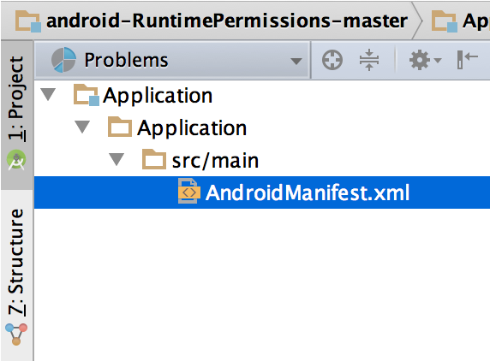

**7.1.2The user interface**

The Android Studio main window is made up of several logical areas identified in figure 3.

1. The **toolbar** lets you carry out a wide range of actions, including running your app and launching Android tools.
2. The **navigation bar** helps you navigate through your project and open files for editing. It provides a more compact view of the structure visible in the **Project** window.
3. The **editor window** is where you create and modify code. Depending on the current file type, the editor can change. For example, when viewing a layout file, the editor displays the Layout Editor.
4. The **tool window bar** runs around the outside of the IDE window and contains the buttons that allow you to expand or collapse individual tool windows.
5. The **tool windows** give you access to specific tasks like project management, search, version control, and more. You can expand them and collapse them.
6. The **status bar** displays the status of your project and the IDE itself, as well as any warnings or messages.

**7.1.3 System Requirements for Android Studio**

**Windows**

* 64-bit Microsoft® Windows® 8/10.
* x86_64 CPU architecture; 2nd generation Intel Core or newer, or AMD CPU with support for a [Windows Hypervisor](https://developer.android.com/studio/run/emulator-acceleration#vm-windows).
* 8 GB RAM or more.
* 8 GB of available disk space minimum (IDE + Android SDK + Android Emulator)
* 1280 x 800 minimum screen resolution.

**Mac**

* MacOS® 10.14 (Mojave) or higher.
* ARM-based chips, or 2nd generation Intel Core or newer with support for [Hypervisor.Framework](https://developer.android.com/studio/run/emulator-acceleration#vm-mac).
* 8 GB RAM or more.
* 8 GB of available disk space minimum (IDE + Android SDK + Android Emulator).
* 1280 x 800 minimum screen resolution.

**Linux**

* Any 64-bit Linux distribution that supports Gnome, KDE, or Unity DE; GNU C Library (glibc) 2.31 or later.
* x86_64 CPU architecture; 2nd generation Intel Core or newer, or AMD processor with support for AMD Virtualization (AMD-V) and SSSE3.
* 8 GB RAM or more.
* 8 GB of available disk space minimum (IDE + Android SDK + Android Emulator).
* 1280 x 800 minimum screen resolution.

**7.2 JAVA**

Java is a programming language and computing platform first released by Sun Microsystems in 1995. There are lots of applications and websites that will not work unless you have Java installed, and more are created every day. Java is fast, secure, and reliable. From laptops to datacenters, game consoles to scientific supercomputers, cell phones to the Internet, Java is everywhere!

**7.2.1 Java Installation**

**Step1:** Download JDK

**Step2:** Install JDK

Open the executable file which you have just downloaded and follow the steps.

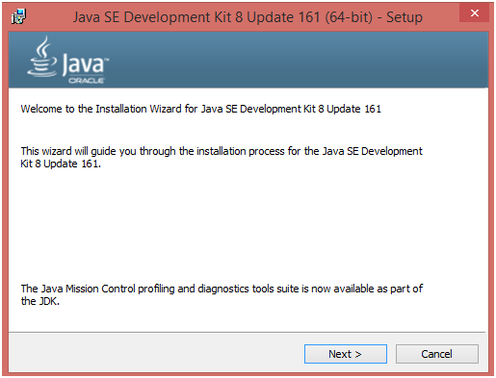

**Step3:** After installing Java we have to set path variable.

**8. Design**

**8.1 Flow chart**

**\**

**8.2 Data Flow Diagram (DFD)**

**9. Implementation**

The proposed system is based on Android Operating system which will remind the users to take medicines on time through notification and automatic alarm ringing system.

Android is a Linux-based operating system designed primarily for touch screen mobile devices such as smart phones and tablet computers, developed by Google in conjunction with the Open Handset Alliance. Android was built from the ground-up to enable developers to create compelling mobile applications that take full advantage of all a handset has to offer. The system is specified on android operating system only because the market share of Android is high. [Android also comes with an application development framework (ADF), which provides an API for application development and includes services for building GUI applications, data access, and other component types. The framework is designed to simplify the reuse and integration of components. Android apps are built using a mandatory XML manifest file. The manifest file values are bound to the application at compile time. This file provides essential information to an Android platform for managing the life cycle of an application. Examples of the kinds of information included in a manifest file are descriptions of the app’s components among other architectural and configuration properties. Components can be one of the following types: Activities, Services, Broadcast Receivers, and Content Providers.

**9.1 Set Alarm module-** It helps in reminding about the medicines. User can add details of his dosage schedules. Using the date field one can enter the starting and ending dates between which he has to take medicines. The time field shows the time of dosage and on that time the alarm will get rung. The user can add the description of the medicine, including name, purpose and other related description. All the information will be saved in the database. This makes any time availability of the patients’ records. They can change the ringtone of the alarm from the ringtones stored in the devices. Figure below shows this module.

Screenshot of Set_Alarm Module

**9.2 Get_Notification module**: Once the alarm is set then the user gets the notification. The users can activate or deactivate this accordingly. If he does not require the notification he can turn off it. If he requires this system then a notification will be sent into his device. Again if he wants the notification in email form, he can select the ‘Notification through Email Mode’ or if he requires it in a message format he can go with ‘Notification through Message Mode’. Figure 4 depicts the module with Notification through Message Mode.

Screenshot of Get_Notification Module

**9.3 Save_Medicine Module:** This module used to take type of medicne and save in database so that when it is time to take medicine it will remind you type of medicine.

**10. Learning Outcomes from Technology Learnt**

**10.1 Java**

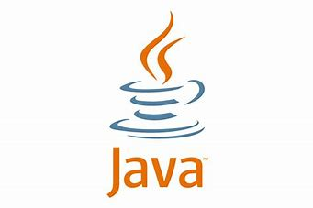

Java is a programming language and a platform. Java is a high level, robust, object-oriented and secure programming language.

Java was developed by Sun Microsystems (which is now the subsidiary of Oracle) in the year 1995. James Gosling is known as the father of Java. Before Java, its name was Oak. Since Oak was already a registered company, so James Gosling and his team changed the name from Oak to Java.

Platform: Any hardware or software environment in which a program runs, is known as a platform. Since Java has a runtime environment (JRE) and API, it is called a platform.

Android coding was done in JAVA programing language. By doing all coding in JAVA I learnt many key features of java and learnt about OOP in JAVA.

**10.2 Android Studio Programming**

Android Studio is the official Integrated Development Environment (IDE) for android application development. Android Studio provides more features that enhance our productivity while building Android apps.

There are a lot of components of android studio and I learnt aout all of them and created a Medicine reminder app.

**11. Gantt Chart**

**12. Project Legacy**

**12.1 Technical and Managerial lessons learnt**

Medicine Reminder App is an Android-based application in which an automatic alarm ringing system is implemented. It focuses on doctor and patient interaction. Patients need not remember their medicine dosage timings as they can set an alarm on their dosage timings.

* I have learnt how to make a fully working application based on android.
* Learnt how to design a application modules.
* Learnt better JAVA and object-oriented programming.
* I have learnt front-end and back-end development in android development.
* Gained more knowledge about android studio.
* Learnt how to give my best in short time.
* Known more about corporate world.
* Completing work under pressure.
* This project work also made my communications skills better.
* I have gained confidence.
* This project has improved my skills.
* Gained knowledge about industrial world project as well.

I really believe knowledge gained from this project will also help me in future. By doing this project I have improved my ability to work for this my level of confidence has increased. I have also gained work experience which has improved me.

**13. Bibliography**

<https://en.wikipedia.org/wiki/>

<https://developer.android.com/studio/intro?authuser=1>

[YouTube](https://www.youtube.com/)

<https://www.geeksforgeeks.org/>

**Book :** Beginning android programming with android studio BY DiMarzio, J. F.